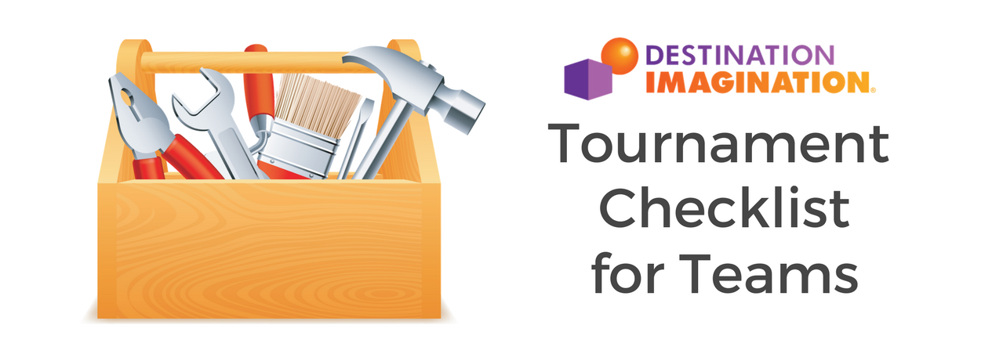
- Tournament Data Form, Expense Report and Declaration of Independence
- Snacks, Lunch and Water
- Props
- Team Identification Sign
- Team Clarifications (If your team requested any Clarifications, you need to bring them to the tournament.)
- Appropriate Clothing
- Umbrella or Tarp (for props)
- Extra Scripts or Notes
- Instant Challenges to practice
- Fix-It Kit (duct tape, makeup, fabric, paint, tools, glue gun, etc.)

